Price change on NCR
Scenario: FC is calling because they want to change the price of one or more items.

- Access to NCR Homepage

"Please provide me with the list of items for which you wish to make a price change." Wait for a response. Once you receive it, repeat the items back to the customer to ensure you have the correct items and prices.

- Click the house icon in the top right corner of the screen.
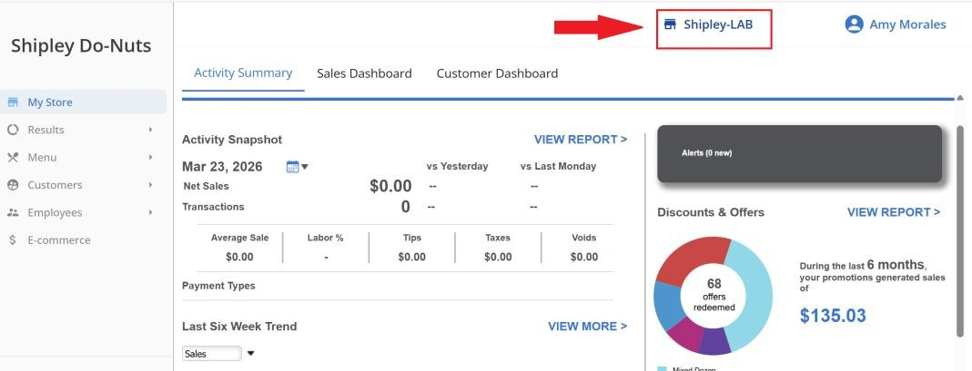

Enter the store number provided by the FC (e.g., FC7992) into the search bar and click on it to access the client’s profile.
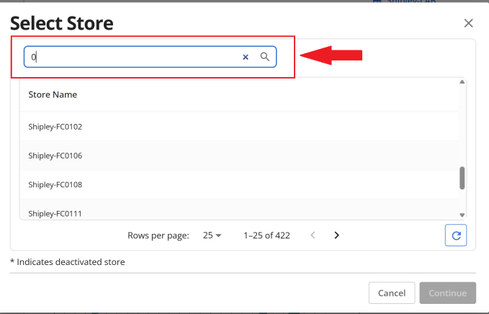

Insert the store number the FC provided to you in the search bar, (e.g. FC7992) and click on it to access the client’s profile.
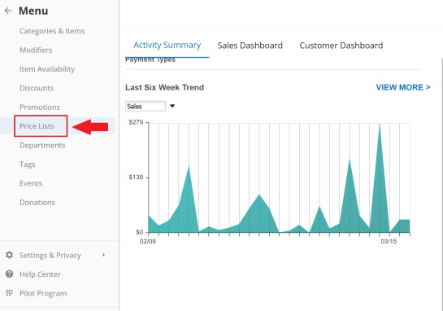
- Select the PRICE LISTS option.
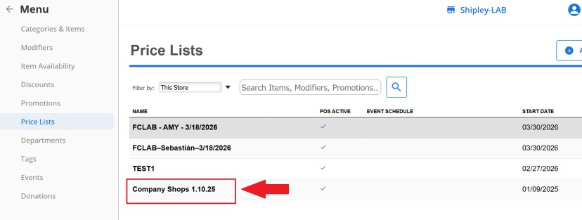
- Select the shop whose prices you want to change.
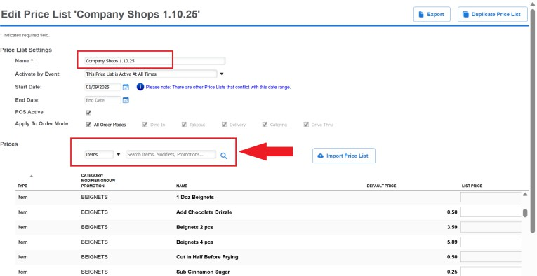
- You will be able to see all the available items in that shop. You can also look for items using the search bar.

- If the item is a parent item, select ITEM. If it is a modifier, select MODIFIERS. If it is a promotion, select

PROMOTIONS.
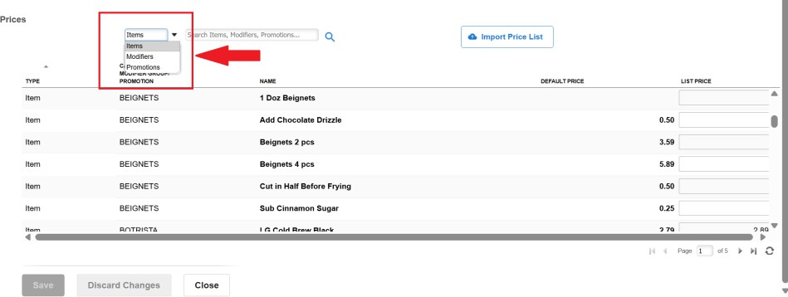
- On the right, you can see the DEFAULT PRICE. This is the price that automatically appears on the menu if no price is set in the LIST PRICE field.
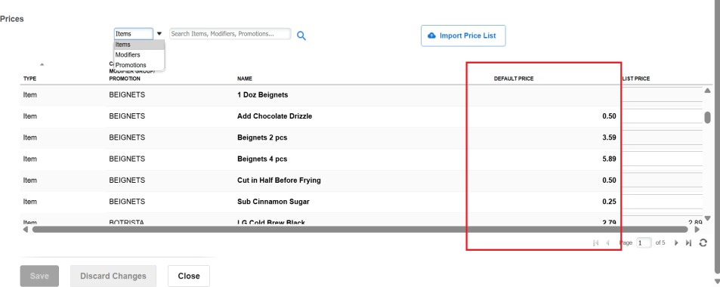
- Type the new price in the LIST PRICE box on the right.
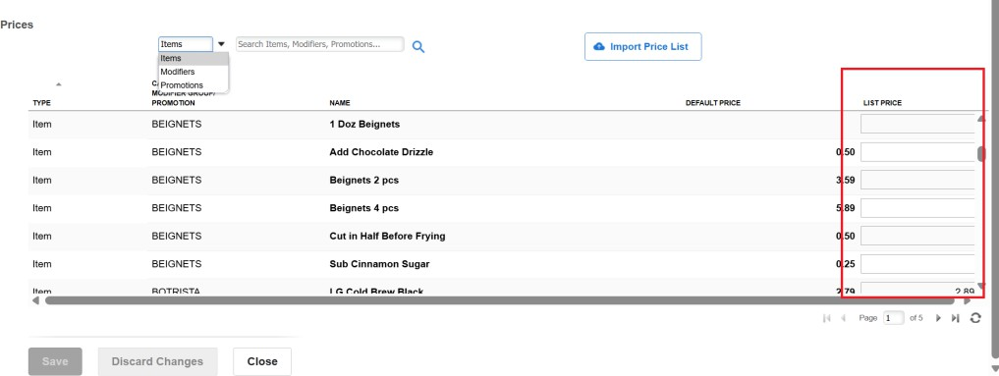

- Use the search bar on the top left to find the item you want to change the prices on.
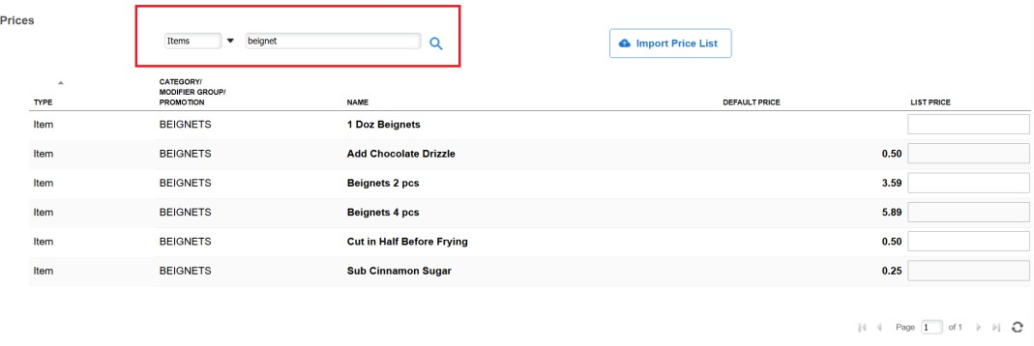
- Choose the item you want to change the price on, and input the new price on the LIST PRICE side.
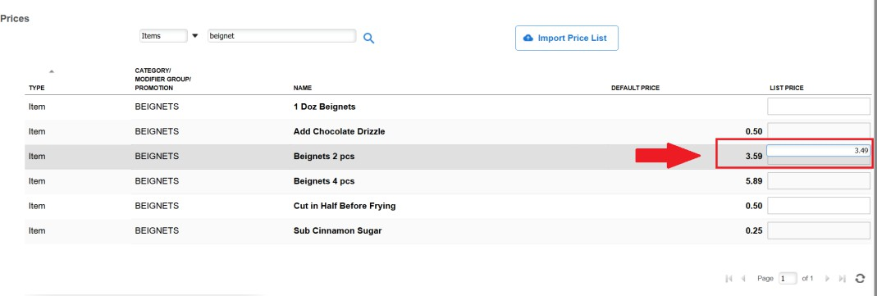

- Press SAVE to confirm the new prices.
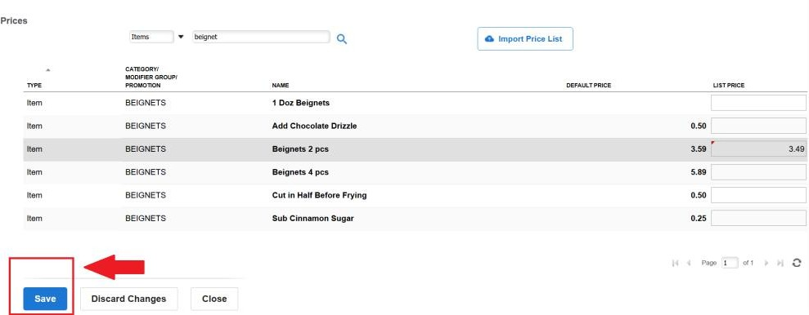
- In a few minutes, the price will be updated across all the shop's systems.

- However, to speed up the process, they can tap the cloud icon in the upper right corner of the POS terminal screen.
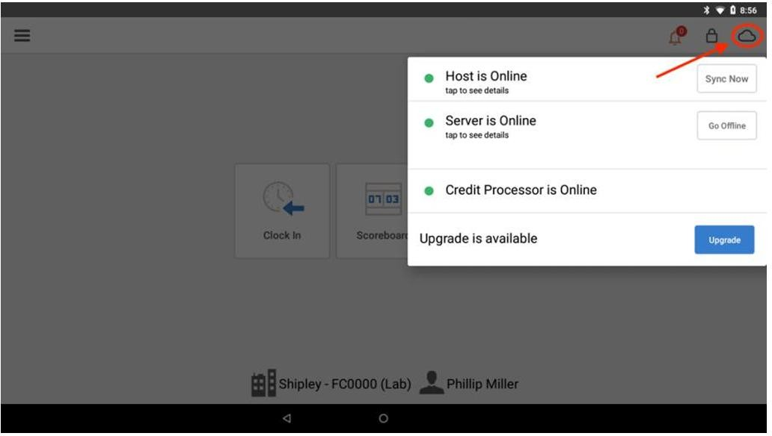
- Select SYNC NOW to synchronize the changes across all devices.
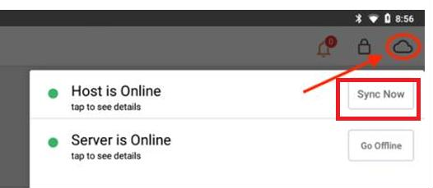

"The changes have been made, and the new prices should now be reflected on all your devices."
Advise the FC to check if the new prices are correct or need to be adjusted.

